AVL Tree
AVL Tree
AVL Tree can be defined as height balanced binary search tree in which each node is associated with a balance factor which is calculated by subtracting the height of its right sub-tree from that of its left sub-tree.
Balanced Factor (BF)
Tree is said to be balanced if balance factor of each node is in between -1 to 1, otherwise, the tree will be unbalanced and need to be balanced.
Balance Factor (k) = height (left(k)) - height (right(k))
If the difference in the height of left and right sub-trees is more than 1, the tree is balanced using some rotation techniques.
- If balance factor of any node is 0, it means that the left sub-tree and right sub-tree contain equal height.
- If balance factor of any node is 1, it means that the left sub-tree is one level higher than the right sub-tree.
- If balance factor of any node is -1, it means that the left sub-tree is one level lower than the right sub-tree.
Examples:
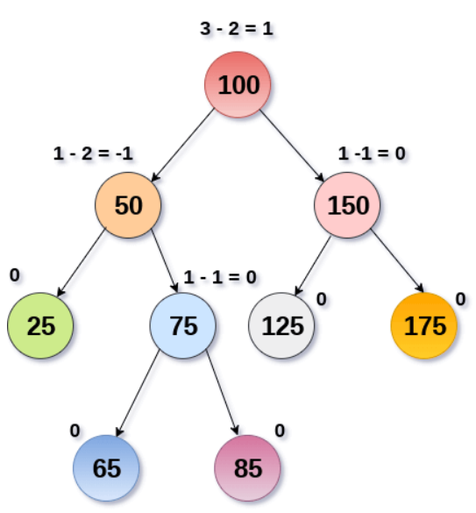
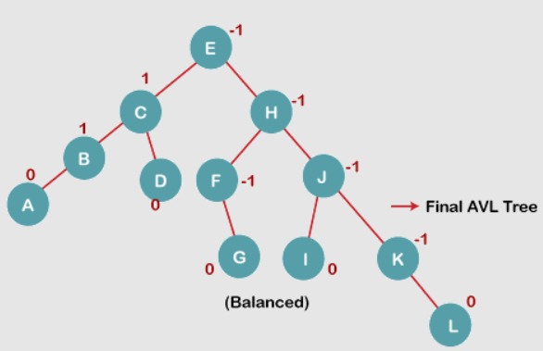
Rotation:
We perform rotation in AVL tree only in case if Balance Factor is other than -1, 0, and 1. There are basically four types of rotations which are as follows:
- LL (Left) rotation: Inserted node is in the right subtree of right subtree of A
- RR (Right) rotation : Inserted node is in the left subtree of left subtree of A
- L R rotation : Inserted node is in the right subtree of left subtree of A. (left rotation is followed by a right rotation)
- R L rotation : Inserted node is in the left subtree of right subtree of A. (right rotation is followed by a left)
The first two rotations LL and RR are single rotations and the next two rotations LR and RL are double rotations. For a tree to be unbalanced, minimum height must be at least 2,
Detailed about rotation:
https://www.educative.io/edpresso/common-avl-rotation-techniques
Operations on an AVL Tree
The following operations are performed on AVL tree.
- Search
- Insertion
- Deletion
Insertion Example:
Construct an AVL Tree by inserting numbers from 1 to 8.
http://www.btechsmartclass.com/data_structures/avl-trees.html
AVL Class Activity:
Question: Insert 3,2,1,4,5,6,7, 16,15,14

